
GIS Library Tutorials – Introduction to ArcGIS Online - 4

Adding a shapefile as a hosted feature layer
Some large datasets cannot be imported directly – instead they are added as feature layers to ArcGIS Online and then added to the map – this exercise shows how to do this using the Ancient Long-Established Woodland shapefile

Left click on Home

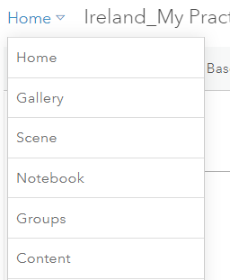
In the menu which opens left click on Content

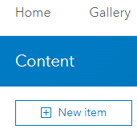
A new window opens left click on New item

In this example left click on Your device as the dataset is saved on your own laptop / PC

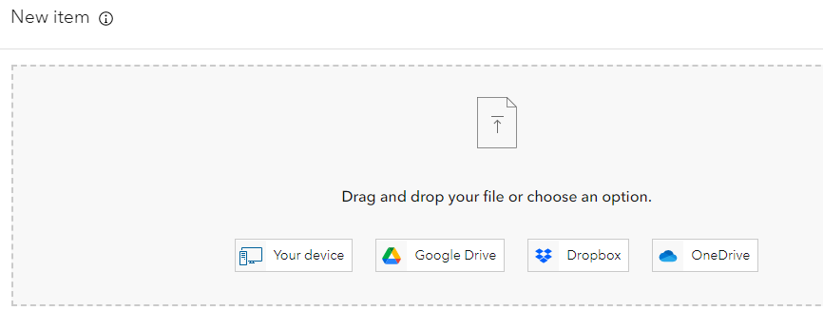
Navigate to your ArcGIS Online folder

Left click on the zipped folder ancient-long-established woodland and left click on Open

N.B The Folder must be zipped… otherwise it will NOT import

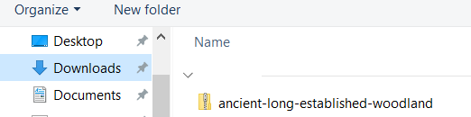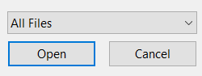

Left click in the first radio button to add the shapefile as a hosted feature layer
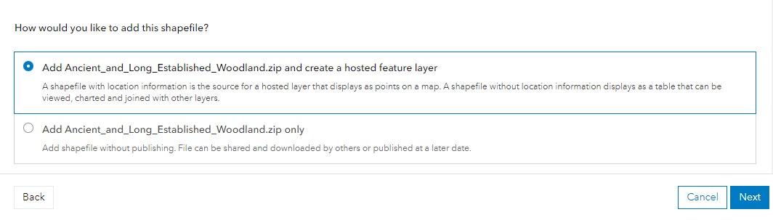
Left click on Next

The title of the zipped folder will be shown in the Title field – but you can rename this if required, i.e., if there is already a layer with the identical name you will be asked to give the layer you are adding an alternative name

Type in some tags, e.g., woodlands - historic - heritage - Ireland and a summary such as
This data is downloaded from the National Parks and Wildlife Service

Left click on Save
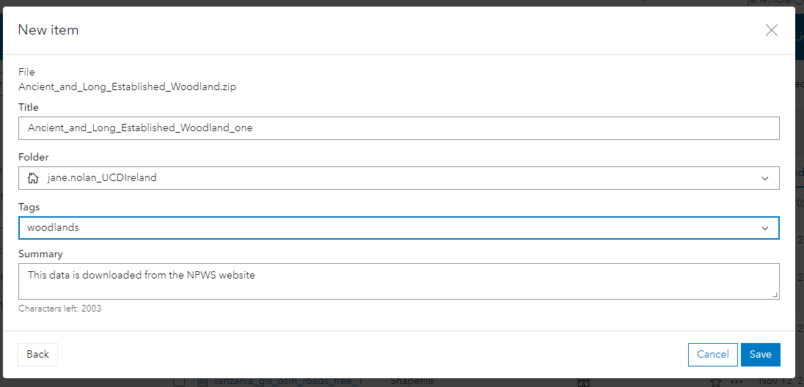

ArcGIS Online now processes this request and shortly you should see the new file in the window as per below
Left click on the Content tab

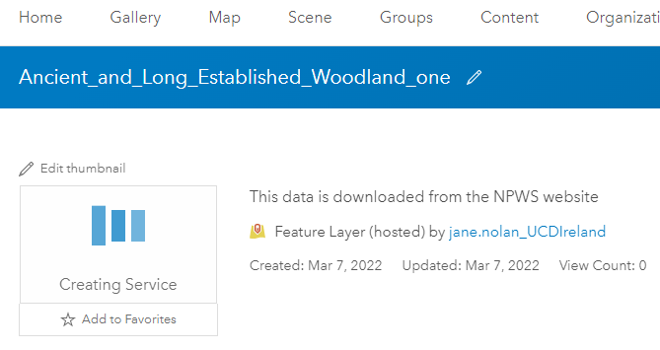

You will see the Ancient woodland which is a feature layer and the Practice web map

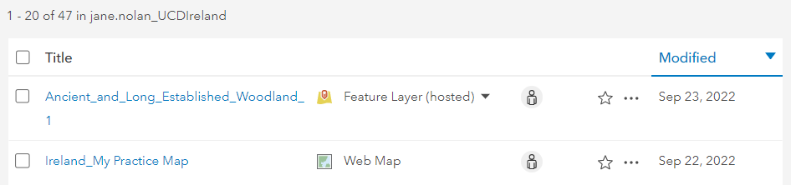
Left click on the person icon next to the Ancient woodland layer to change sharing options

The default is for the layer to be owned and accessible ONLY to the owner (i.e., the person who added the layer). Left click in the radio button for Everyone so that this layer will be visible when the map you create is on a website

Left click on the Save button 
The previous window opens (you can now see that the ancient woodland layer has the globe icon next to it)



Left click on your Ireland Practice Map to open your map again



Left click on Open in Map Viewer Classic

To search for the Ancient Woodland layer, left click on the Add button, then left click
on Search for Layers
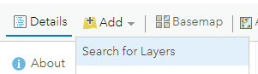

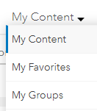
Left click on My Content

This opens a drop-down menu – left click on My Content
You should now see the Ancient and Long-Established Woodland layer
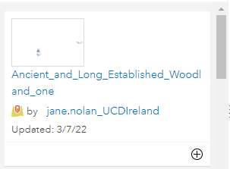
To add this layer to your map, left click on the + symbol
Left click on Details and then the Content tab to see the data layers in the map
Hide the Electoral Divisions by clicking in the checkbox to remove the tick
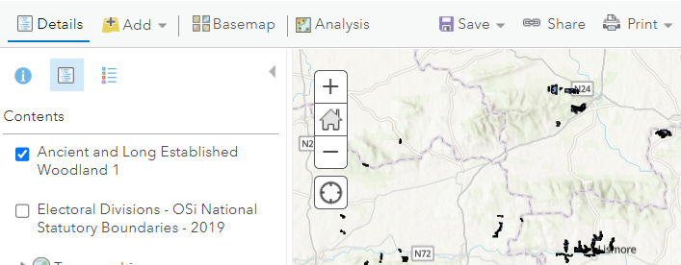

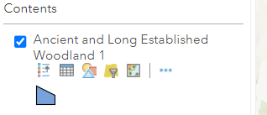
Left click on the Legend icon to see how the Woodland layer is symbolised on the map
In this example, the woodland layer is symbolised in blue polygons
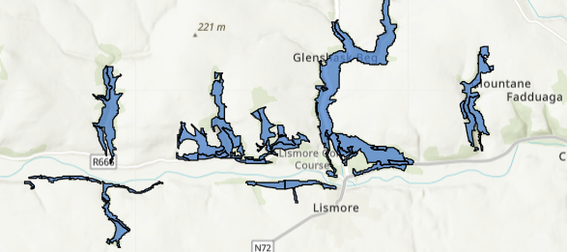

Left click on Save 

